**Name: Arya Kashikar**

**PRN: 22070521036**

**Course- Certified System Administrator**

**Lab 1.3.1 – 1.3.3**

* **Create Incident Using Classic Lists and Forms**
* **Section 1: Explore ITSM and Incident Management Capabilities**

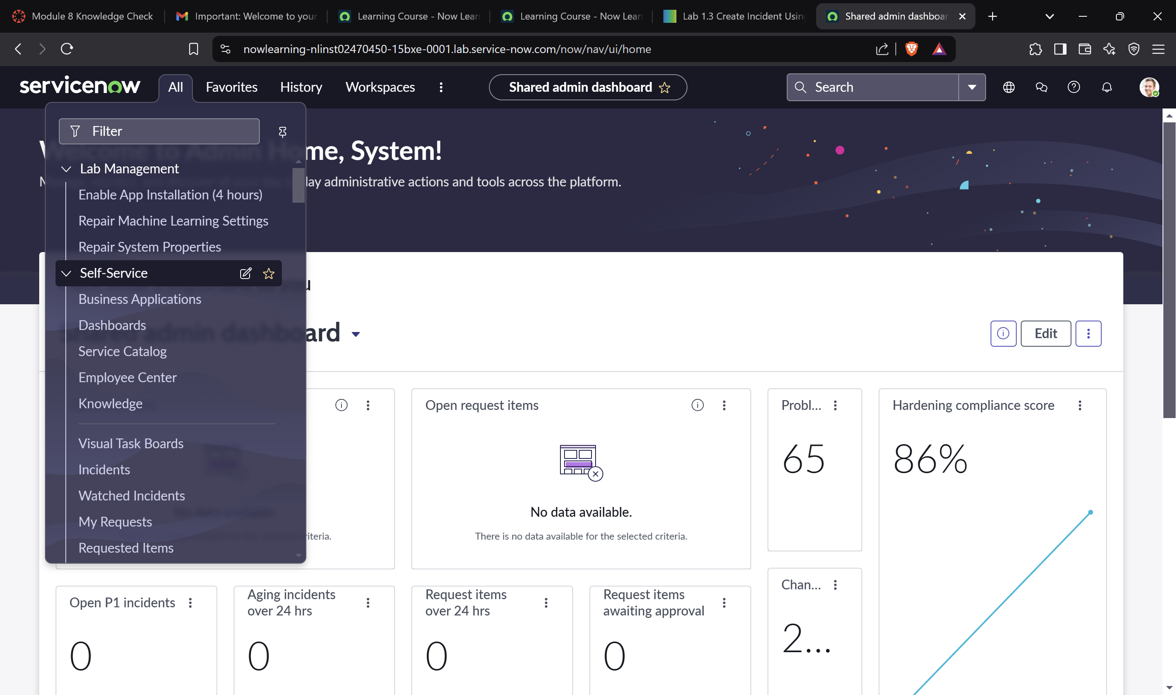

* **Section 2: Create a New Incident in the Classic Environment**

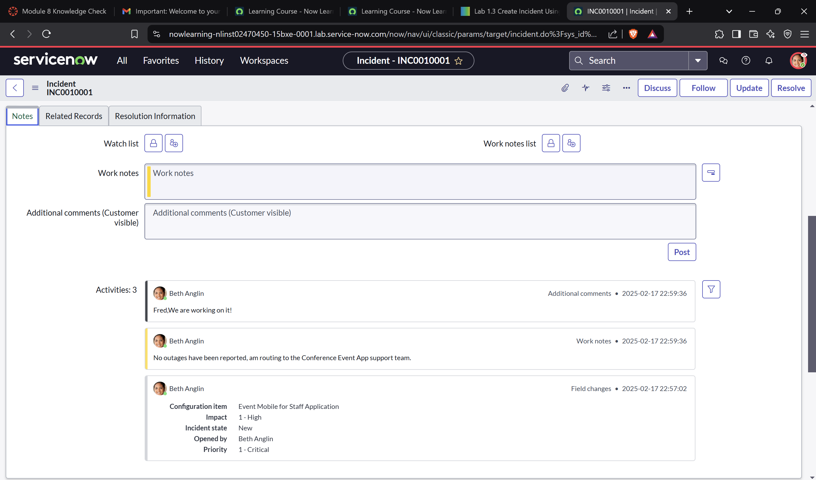

* **Section 3: Explore Incident Lists in the Classic Environment**

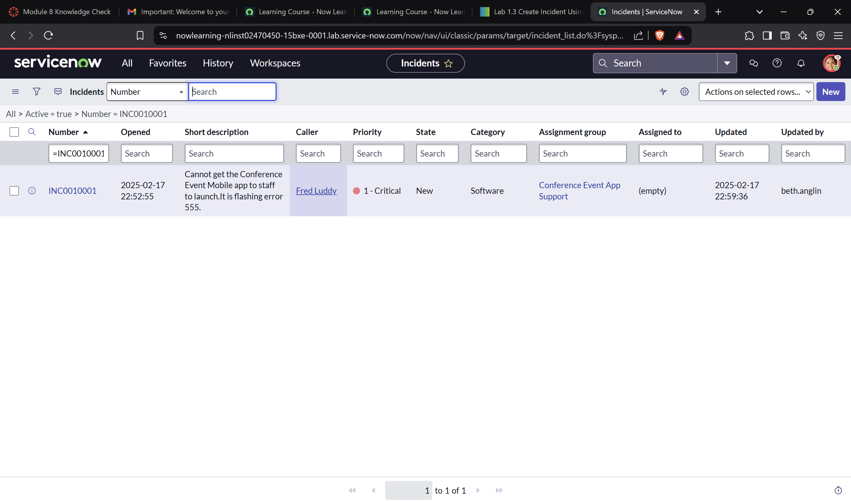

* **Section 4: Receive Work Assignments in the Classic Environment**

